BOLIVIA

When: 2017–2019

Purpose: Strengthen national analytical capacity on three priority areas: (1) scaling up ethanol production; (2) redirecting soybean oil exports toward domestic biodiesel production; and (3) assessing the cross-sectoral impacts of large hydropower projects.

What happened: In the context of Bolivia’s Law No. 1098 (2018), which promotes biofuel production to reduce fuel imports and enhance energy security, a CLEWs model was co-developed through a series of technical workshops & inter-institutional collaboration. The model assessed the implications of increasing bioethanol production to meet up to 25% of national gasoline demand. The analysis focused on scaling up sugarcane production and explored associated cross-sectoral impacts on land use, water resources, and agricultural systems.

Key insights: The modelling showed that achieving ethanol targets through land expansion would require approximately 80,000 additional hectares for sugarcane, potentially leading to deforestation (particularly in the Amazon) and thus revealing a critical trade-off between energy policy & land sustainability. Results highlighted that meeting biofuel targets sustainably depended on improving agricultural productivity & irrigation efficiency rather than expanding cultivated areas.

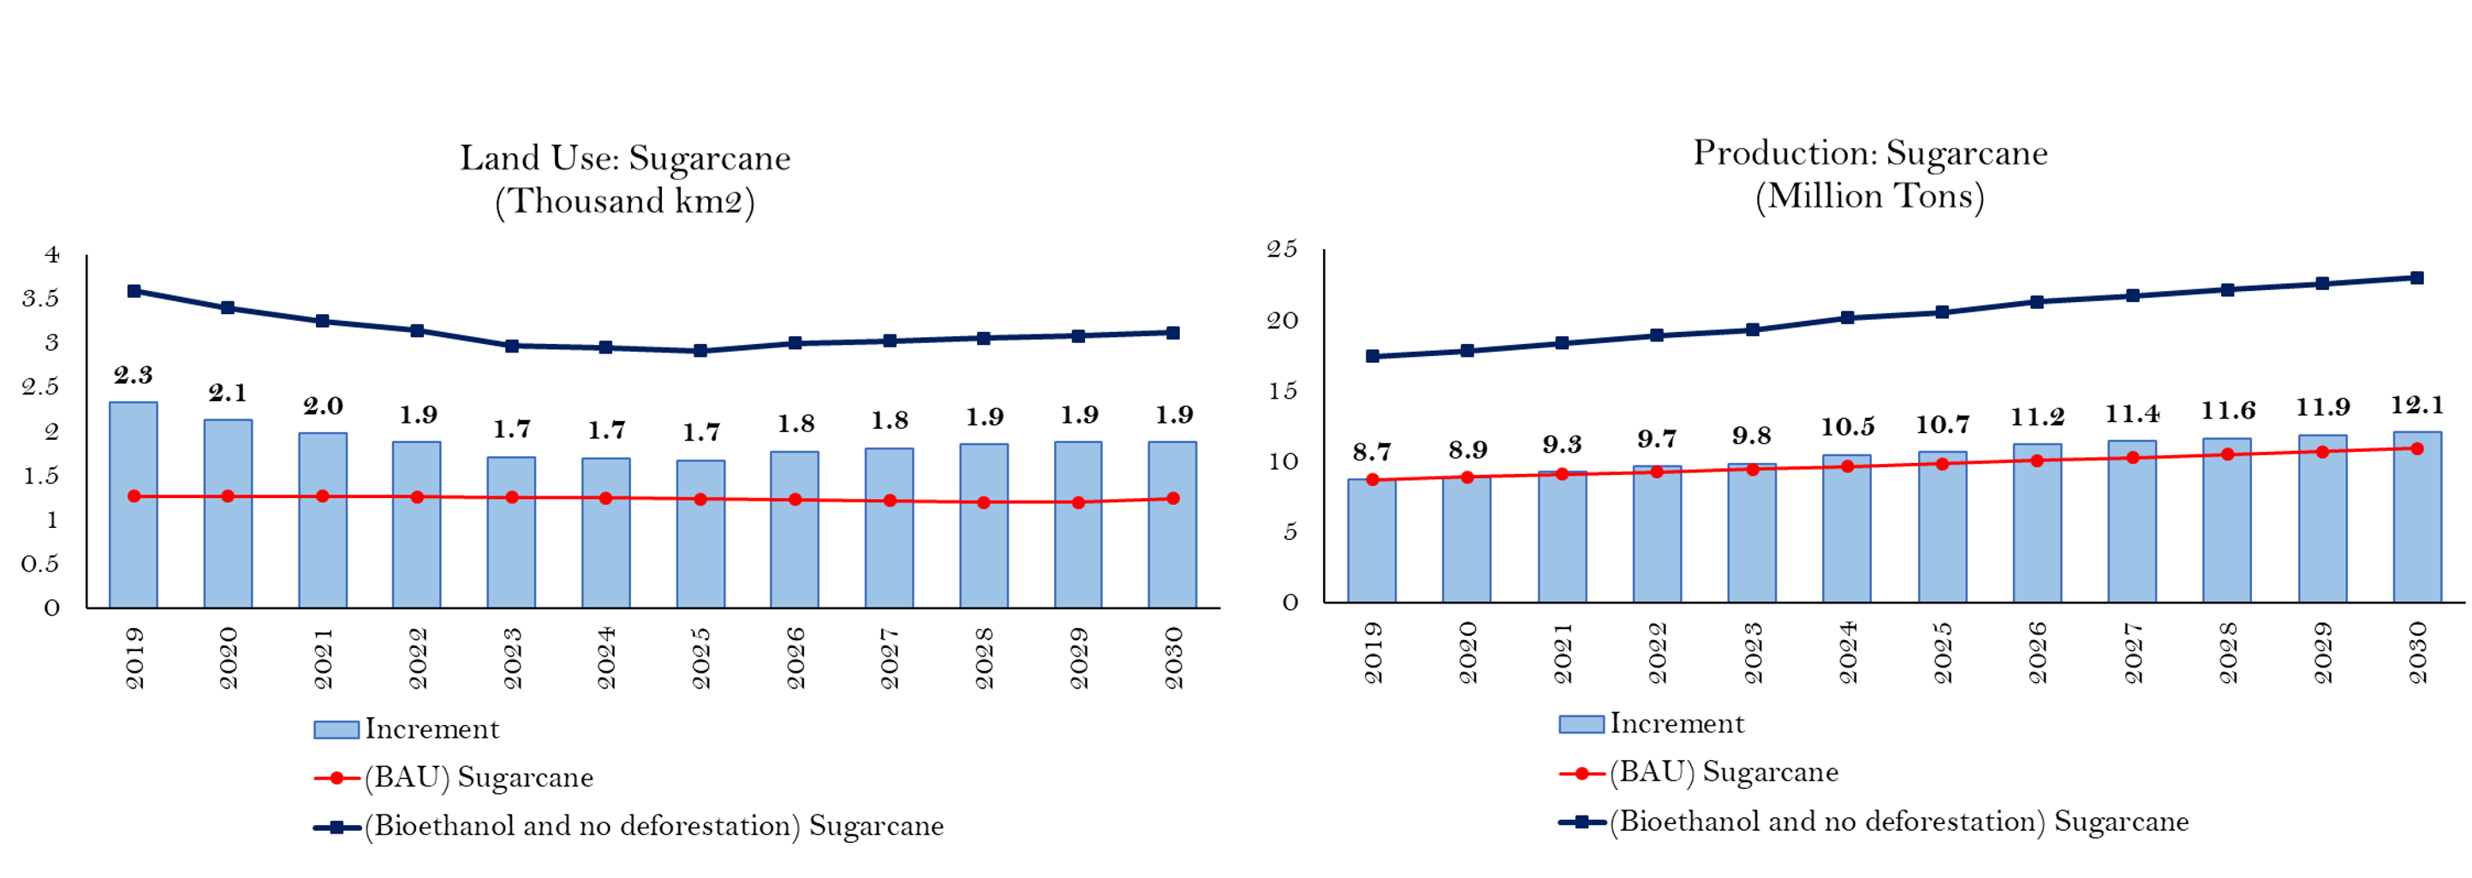

The analysis also underscored the importance of accounting for investment needs, seasonal production dynamics, and the role of by-products (e.g., bagasse) to better capture system-wide impacts.

Resources: No formal policy notes were published since the project was interrupted by the 2019 political crisis in Bolivia, followed by the COVID-19 pandemic. However, results were presented at an IAEA event in 2018 by a government official trained through the project. (see: Presentation for IAEA_Nov2018_Osmar.pptx).

Models: OSeMOSYS & LEAP

Stakeholders: Government of Bolivia (Unit of Social and Economic Policy Analysis – UDAPE; Ministry of Energy; Ministry of Hydrocarbons; Ministry of Planning of Development; Ministry of Environment and Water), supported by UN DESA, UNDP, KTH-dESA, SEI-US, and IAEA

Insert: NAEZ of Bolivia

Tags: #Climate #Energy #Water #Land #Biofuel #Agriculture #Deforestation

DOMINICAN REPUBLIC

When: 2023–2025

Purpose: Strengthen alignment between the Long-Term Strategy and the National Development Strategy because the Dominican Republic faces growing water scarcity due to inefficient irrigation, agricultural expansion, and climate change.

What happened: Three scenarios were analyzed:
- Baseline without additional policies or technological improvements (BAU)
- Irrigation technification & productivity improvements (TNR)
- Reduced precipitation based on climate projections (DPP)

Key insights:
- Water stress is the key systemic constraint, with national stress levels around 56% and agriculture consuming 82% of total water use, creating cascading impacts across energy, land, and ecosystems.
- Irrigation inefficiencies amplify cross-sector pressures, but modernization (technification) emerges as a high-impact solution — potentially reducing water use over 40% by 2050 while increasing yields and easing pressure on forests & water resources.
- Water–Land–Productivity dynamics are tightly interlinked, with business-as-usual pathways leading to deforestation & resource degradation, whereas efficiency improvements can stabilize land use and enhance overall system performance.
- Climate change will existing vulnerabilities through reduced precipitation (15–17%) and declining agricultural yields by 2050. Integrated policy approaches, particularly irrigation modernization, can deliver co-benefits, including lower costs, reduced emissions, improved resilience, and strengthened food production.
- 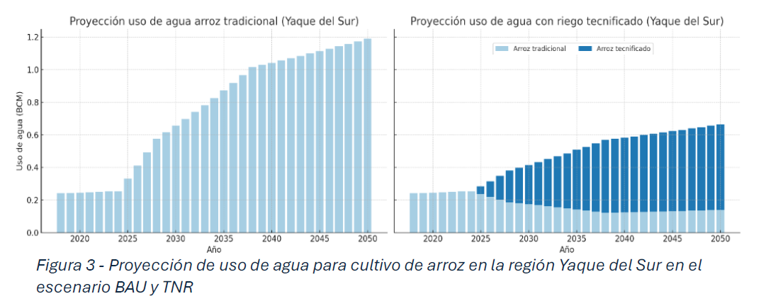

Resources: Insert Nota de Política:

Models: OSeMOSYS

Stakeholders: Ministry of Economy, Planning & Development (MEPYD), RCO Dominican Republic, UN DESA, and the Climate Lead Group (CLG).

Tags: #Agriculture #Water #Climate #Land #Deforestation

ETHIOPIA

When: 2018–2021

Purpose: Address 3 policy priorities: Modern Agriculture + Manufacturing Sector + Climate-Resilient Green Economy given that Ethiopia’s 10-year National Development Plan (2020–2030) has to face a rapid population growth & urbanization. Together with its economic growth, it results in growing competing demands for resources (land, energy, water) under ongoing climate change impacts.

What happened: The project established an inter-institutional team of experts from various sectors, enabling coherent discussions on national development strategies. A roadmap for institutional integration of CLEWs was developed, and the CLEWs approach was incorporated into the country’s UNSDCF.

Key insights in Agriculture:
- Substantial potential for modernization of agriculture. Yields could improve by 50 to 110% through greater use of inputs & mechanization.
- Productivity improvements would reduce the need for additional cropland, but does require additional inputs of energy, water, pesticides, and fertilizers.
- Requires substantial increase in investment & inputs. Annual investment would need to be 2-3 times higher than present average.
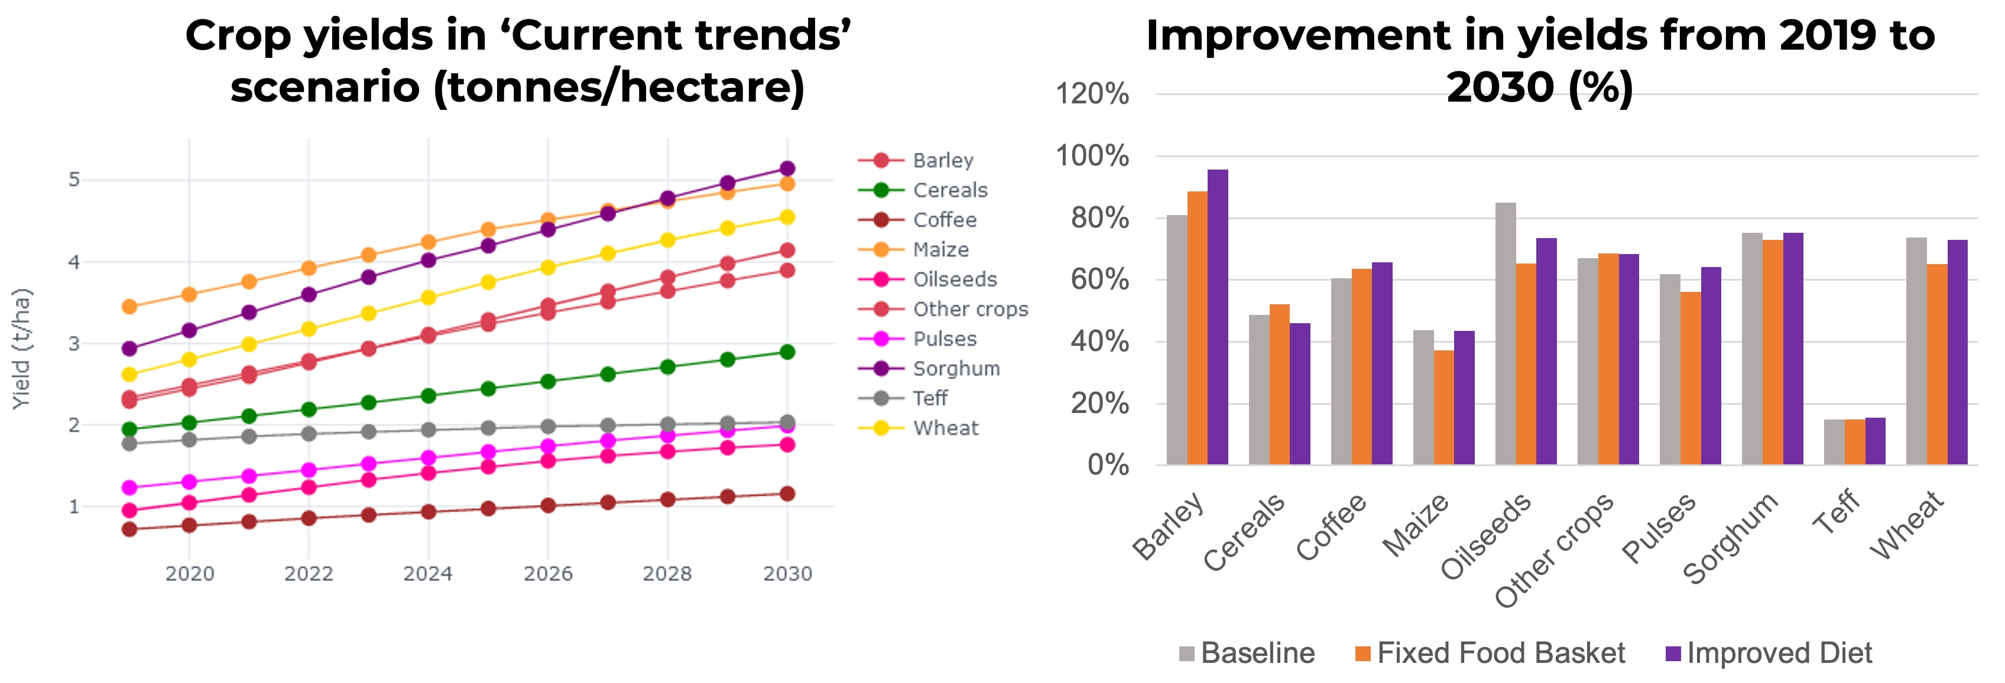

Key insights in Manufacturing:
Four scenarios were developed to inform the manufacturing sector’s expansion target. The first assumes a business-as-usual, fixed demand structure with no change in the composition of energy use, combined with a gradual 1.6% annual improvement in energy intensity. The other three scenarios introduce structural shifts in industrial energy demand, aligning it with low, medium, and high energy intensity benchmarks based on the Philippines, Bangladesh, and India, respectively, to reflect alternative pathways of efficiency & industrial development.
- Electricity demand increases significantly, requiring an additional 5–20 TWh for the industrial sector.
- Industrial heat demand rises sharply, with an additional 34–97 PJ of fuels needed for steam & direct heat.
- Emissions increase substantially, reaching 60–270% above 2019 levels.
- Water demand triples for industry, though it remains a relatively small share of total water use.
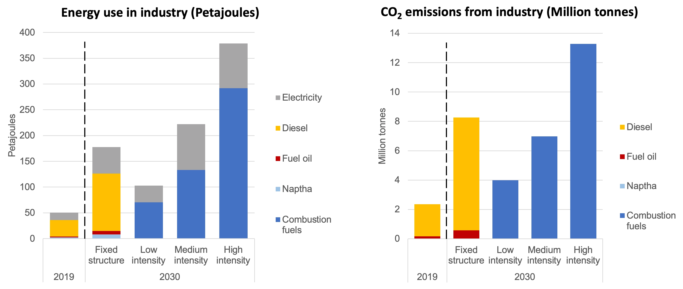
Key recommendations for Green Economy:
- Reforestation allows for increased sequestration of CO2, offsetting emissions from other sectors.
- Crop yields are not significantly affected by climate change, with potential overall increase due to increased rainfall.
- Impacts vary by crop & region, so it’s important not to generalize and consider negative regional impacts for farmers of vulnerable crops.
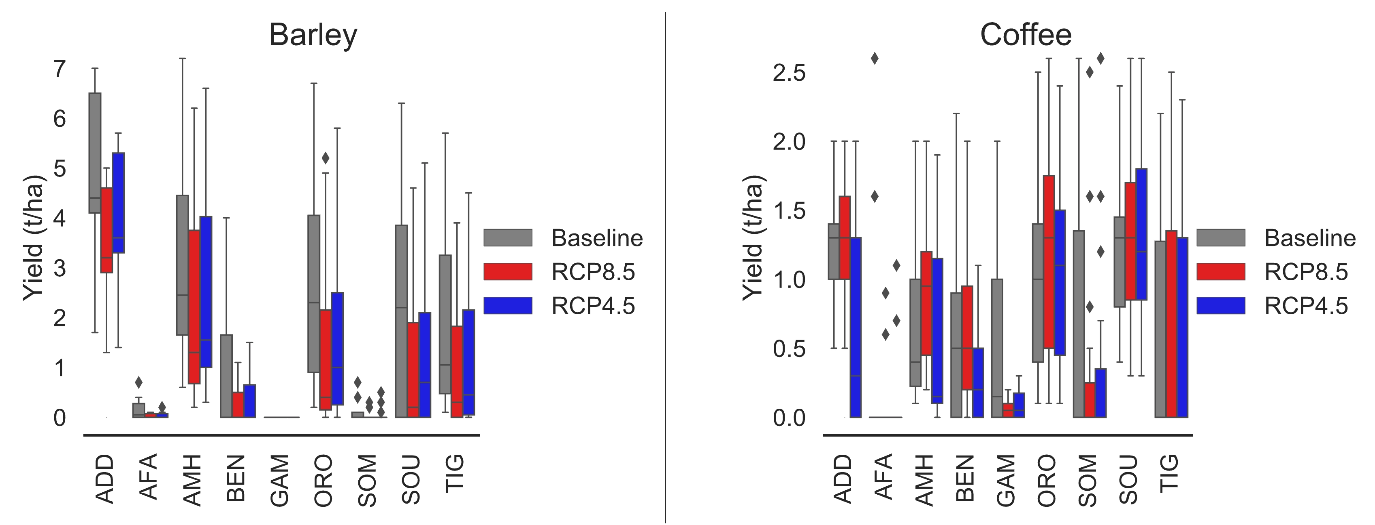
Resources: The project has been documented in a website, including results & model documentation. https://clews-ethiopia-model.readthedocs.io/en/latest/index.html

Models: OSeMOSYS

Stakeholders: The Government of Ethiopia (Ministry of Water, Irrigation and Energy- MoWIE), supported by UN DESA, UNDP, UN ECA, and KTH
Tags: #Agriculture #Manufacturing #GreenGrowth

LAO PDR
When: 2024–2026
Purpose: Achieve Laos’ Green Growth Strategy’s afforestation targets while ensuring food security as per the Agriculture Development Strategy 2025 and respecting the Land Use Master Plan.
What happened: Through an inter-ministerial process, the team designed scenarios to assess how to achieve afforestation targets while promoting climate-resilient agriculture. The on-going, limited cross-sector coordination highlighted the need for integrated planning through frameworks like CLEWs, particularly in countries where agriculture remains central to the economy & livelihoods but pose a development challenge due to rising irrigation demand and land-use change.
Key insights: In the business-as-usual scenario, expanding forest cover reduced available agricultural land, driving more intensive irrigation and increasing both water use & electricity demand for pumping. In contrast, climate-resilient rainfed agriculture reduced reliance on irrigation & energy use.
- Promote sustainable mechanization of agricultural practices to provide an extra 420,000 tonnes of rice per year while saving 8,000 km2 of land.
- Plan water & energy infrastructure in parallel with afforestation targets because the mechanization will result in a +51% water consumption for irrigation and +34% power consumption by 2055.
- Additional power demand can be met through a minimal increase of solar (+1.2) and wind (+2.5%).
- Support the shift to climate-resilient rainfed rice varieties such as nationally developed thadokkham varieties (TD11), in particular in the north, with a–25% cost.
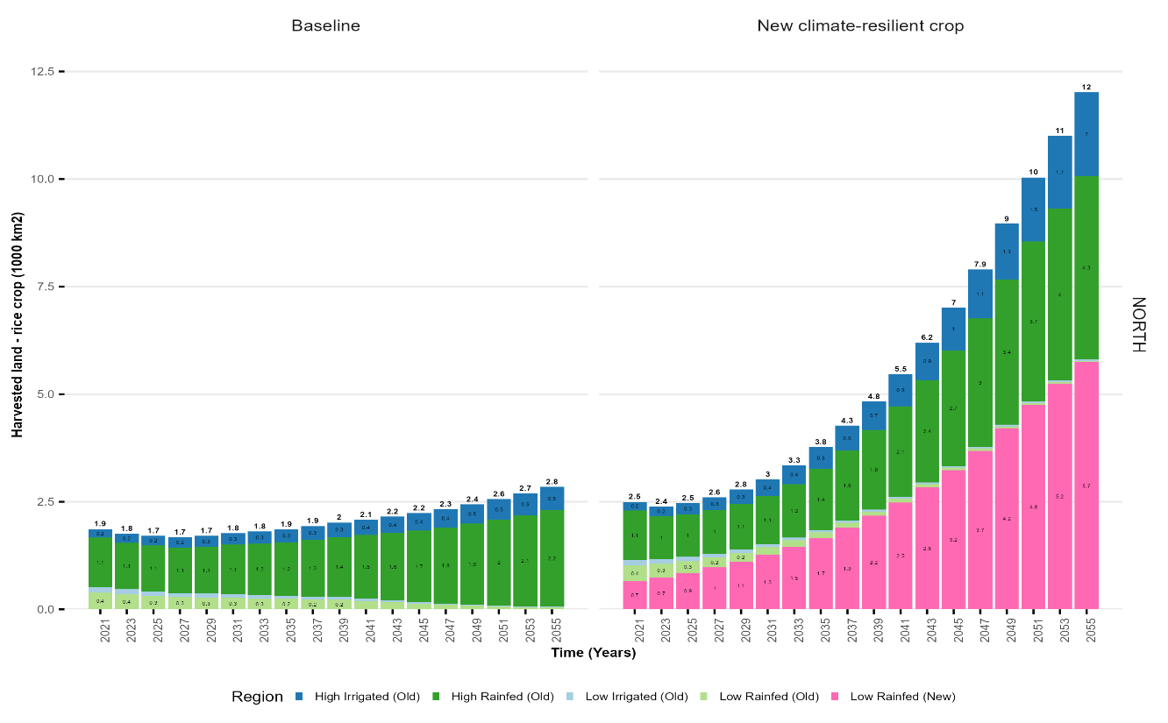

Tools: OSeMOSYS
Stakeholders: UN DESA, Royal Institute of Technology (KTH), Climate Compatible Growth (CCG), National University of Laos
Tags: #Agriculture #GreenGrowth

MAURITIUS

When: 2023–2026
Purpose: Explore scenarios to achieve a 60% renewable electricity target by 2035, while identifying data gaps & priorities for further model development.
Context: The country is actively pursuing economic diversification & resilience, with increasing emphasis on the digital economy, renewable energy, and the blue economy. However, this transition takes place under significant resource constraints: mainly limited land & water availability, plus continued dependence on imported energy & food. As a result, expanding one sector (solar energy, tourism, agriculture) is bound to create competing pressures on others — hence the need for an integrated analysis.
Key insights: ???
Resources: ???
Note, there is a case study / visualization exercise based on a CLEWs model of 2013 that is hosted in the UN Modelling Tools for Sustainable Development Policies website. Do we want to add any reference here? https://un-modelling.github.io/clews-mauritius-presentation/

Tools: OSeMOSYS

Stakeholders: University of Mauritius, UN DESA, KTH, MCO Mauritius and Seychelles
Tags: #SIDS

MEXICO

When: 2017–2023

Purpose: The project was structured around three CLEWs components, developed at different stages and with different partners:

(1) rational water planning in central Mexico using the WEAP model

(2) assessment of the potential of Mexico’s main crops and their water requirements under current & future climate scenarios using the AEZ model

(3) pathway analysis for renewable energy transitions using the OSeMOSYS model

Context: As a developing country with moderate levels of emissions, Mexico has made a commitment to redress climate change and move towards sustainable development, including by passing a General Climate Change Law. Following the ratification of the Paris Agreement, the finance & environment ministries requested support to build capacities in the use of modelling tools & integrated assessment methodologies to address interlinkages & trade-offs among goals, priorities, and sectoral policies.

Key insights:

The agricultural analysis showed the potential impacts climate change on crop suitability, yields, and water requirements across regions, highlighting the increased vulnerability in water-scarce & temperature-sensitive areas.

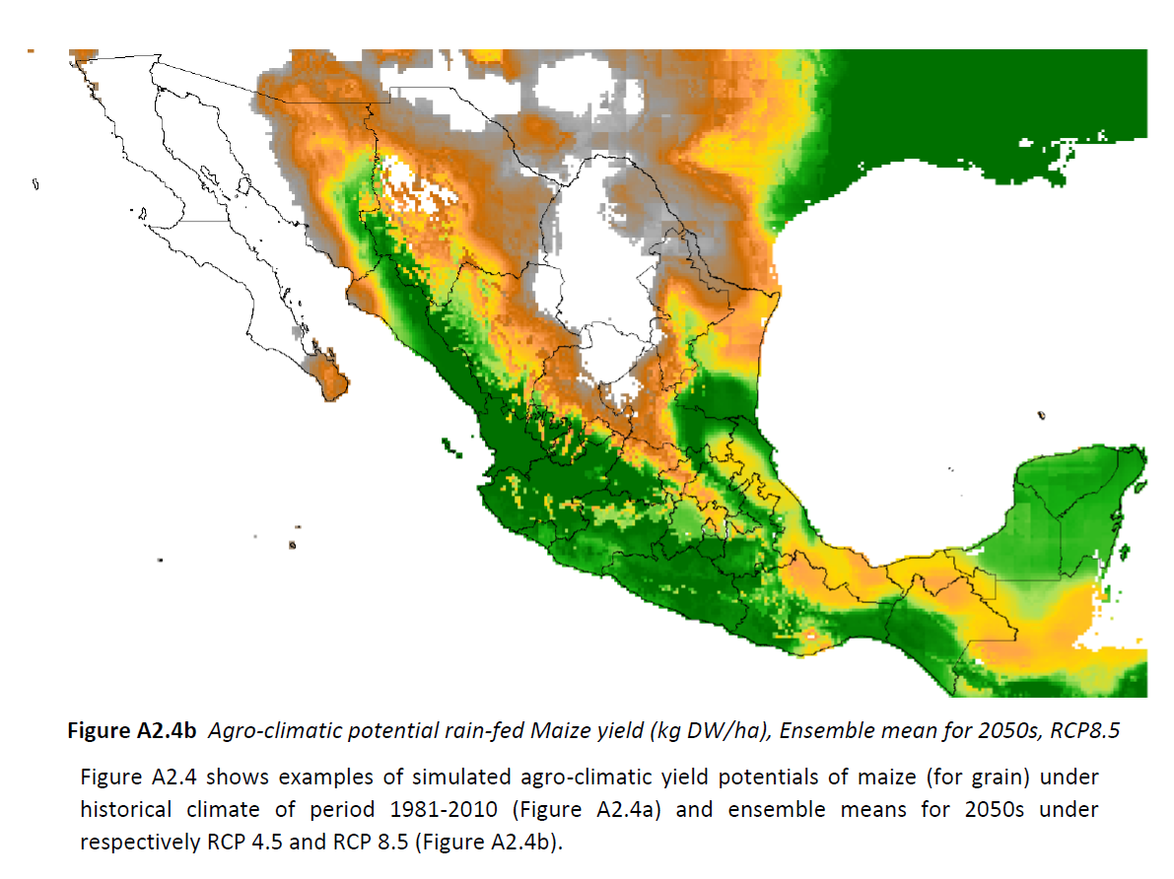

The energy analysis showed that Mexico’s power system (currently heavily reliant on natural gas) can transition toward a high share of renewables over the long term thanks to declining technology costs, though with implications for investment needs and system integration.

Tools: Water Evaluation and Planning (WEAP), Agro-Ecological Zones (AEZ), Open Source Energy Modelling Systems (OSeMOSYS).

Stakeholders: The Government of Mexico’s Secretary of Environment & Natural Resources (SEMARNAT), National Institute for Ecology & Climate Change (INECC), Energy Secretariat (SENER), UN DESA, UNDP, ECLAC, and IIASA.

Resources: Insert [Reporte preliminar de avances en la modelación WEAP para el desarrollo de políticas sustentables en la región central de México.pdf] / AEZ Report?
Topics/tags: #RenewableEnergy, #Agriculture, #Water

MONGOLIA

When: 2020–2021

Purpose: Address the sustainability challenges of the livestock sector, which plays a central role in the country’s economy, employment, and cultural identity.

Context: The livestock sector is characterized by extensive pastoral systems that are increasingly under pressure from overgrazing, land degradation, and rising greenhouse gas emissions—particularly from enteric fermentation. Policymakers face a “trilemma” between increasing livestock production, restoring pasture health, and reducing emissions in line with national climate targets (NDCs). The CLEWs model was developed to explore these interlinkages and assess pathways for balancing economic growth, environmental sustainability, and climate commitments over the period 2015–2035

What happened: ?????

Key insights:
- Clear trade-offs across livestock, land, and emissions: Under business-as-usual, livestock numbers increase, leading to further pasture degradation and rising emissions, highlighting the unsustainability of current trends.
- Pasture rehabilitation is a key policy lever: Improving pasture health reduces land degradation (up to ~67–69%) and allows for lower livestock numbers while maintaining or increasing productivity.
- Productivity gains enable sustainable intensification: Scenarios show that fewer but more productive animals (e.g., +25–41% milk productivity, +11–25% meat productivity) can meet output goals while reducing environmental pressures.
- Climate targets are achievable with integrated strategies: Combining pasture restoration with productivity improvements can reduce emissions by up to ~20% by 2030, supporting Mongolia’s NDC targets while sustaining the livestock sector.

Tools: OSeMOSYS

Tags: #Livestock #LandUse

NAMIBIA

When: 2022–2024

Context: The CLEWs Namibia project aimed to strengthen national capacity for integrated analysis across climate, land, energy, and water systems to support evidence-based planning towards the NDP6. Since 2022, government institutions, the University of Namibia, and UN partners collaborated to develop and apply a country-specific CLEWs model, supported by a technical working group and institutional arrangements for cross-sector coordination. Steps were also being taken to establish a CLEWsLab, as the need to have in-country capacity to support integrated and coherent policymaking was recognized by the government.

What happened: A series of online collaboration working sessions and in-person workshops were conducted to develop a CLEWs model. The model calculates the technology mixes in the energy, water and land use sectors (in terms of installed infrastructure and operation) that meet exogenously defined commodity demands (energy, food crops, livestock and water) between 2019 and 2040 at the lowest cost and constrained by availability of resources and policies. Using this framework, scenarios were developed around four priority areas: i) renewable energy, ii) food security, iii) modernization of agriculture and iv) co-benefits of bioelectricity generation, with water security and climate resilience as cross-cutting issues.

Key insights:
- Renewable energy expansion (REF scenario / energy policy): Under least-cost planning assumptions (aligned with NIRP 2022), solar PV and wind emerge as the most cost-competitive options, supplying the majority of future electricity demand growth. This supports prioritizing renewable investments over new fossil-based generation.
Power supply in the REF scenario

- Food security: Reducing dependence on maize and wheat imports increases domestic production, but also raises demand for water and energy (e.g. irrigation and diesel use), potentially exacerbating existing resource constraints.
- Water scarcity: Total water use approaches or exceeds available renewable resources across all scenarios, making it a binding constraint.
- Food security trade-offs: Increasing domestic crop production raises water and energy demand, intensifying resource pressures.
- Agricultural modernization: Improved irrigation efficiency can offset added water demand from food security policies.
- Bioenergy co-benefits: Biomass power from encroacher bush supports energy supply while enabling productive land use (e.g. grazing).

Tools: CLEWs

Stakeholders: National Planning Commission (NPC), Ministry of Agriculture, Water & Land Reform (MAWLR), the National Statistics Agency (NSA), Ministry of Mines & Energy (MME), UN DESA, UN ECA, KTH, FAO
Tags: #NDP #Agriculture

ZAMBIA

When: 2024-2025

Tools: CLEWs
Stakeholders: University of Zambia, KTH Royal Institute of Technology, Centre for Energy, Environment and Engineering of Zambia, Zambia Electricity Supply Corporation, Energy Regulation Board, UN DESA

Context: Zambia is pursuing universal energy access, agricultural growth, and sustainable land use under frameworks such as the National Energy Compact and IRP. Ambitious crop targets for maize, wheat, and soybean will increase demand for land, water, and electricity, especially for irrigation. The CLEWs framework is used to assess these interlinkages.

What happened: CLEWs scenarios (AgriBoost, AgriBoostPlus, GreenShift) were developed to assess agricultural targets, solar PV for irrigation, and renewable energy alignment. Results show a 71% increase in harvested land, major growth in water use (up to ~9.2 billion m³), and a 12× rise in electricity demand. Land-use changes increase emissions, while solar and wind emerge as least-cost solutions for supporting both agriculture and energy goals.

Key insights
- Integrated planning across land, water, energy, and agriculture is critical to achieving national targets and avoiding resource bottlenecks.
- Agricultural expansion creates significant trade-offs, including increased pressure on groundwater resources and higher emissions from land-use change.

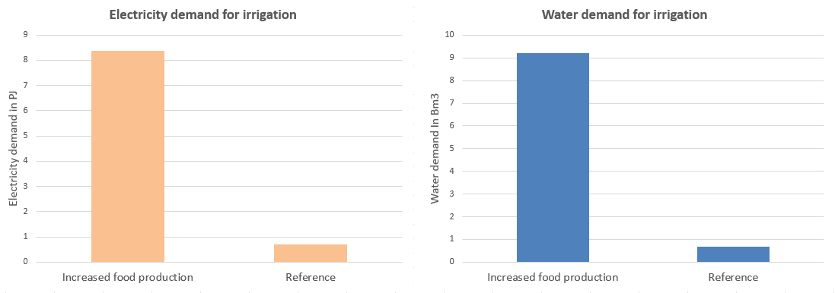
Figure 1 Use of water for crop irrigation (featuring the National Energy Compact's production targets for maize, wheat, and soybean) vs the Reference scenario (same as the former but without the targets) by 2050.

- Electrification of irrigation is a key driver of future energy demand and requires substantial infrastructure investment.
- Distributed solar PV can support small-scale farming, improve resilience to drought, and provide a cost-effective solution for irrigation, though its emissions impact is modest unless deployed at scale.
- Scaling up non-hydro renewable energy (solar and wind) creates synergies between energy transition and agricultural development, while reducing reliance on hydropower and coal.
- Strong institutional coordination and spatial planning are essential to manage competing demands for land and ensure sustainable outcomes.
- Achieving these targets will require significant investment (estimated at around USD 18 billion by 2050) and improved policy alignment.

Resources: Policy Brief

Tags: #AgricultureModernization #SolarEnergy #LandUse #FoodSecurity

BHUTAN
When: 2020-2021
Purpose: Assess how Bhutan can pursue energy security and food self-sufficiency while maintaining its carbon-neutral commitment under NDC 2.0. The analysis focused on managing climate-sensitive land, energy and water resources, given Bhutan’s dependence on agriculture and hydropower, and its constitutional mandate to maintain at least 60% forest cover

What happened: A national CLEWS model was developed for 2020–2035 using 2017–2019 baseline data. It analyzed energy demand, fossil fuel use, hydropower, agriculture, land availability and GHG emissions under BAU and low-emission pathways. Food security scenarios also tested self-sufficiency targets, climate impacts and irrigation.
Key insights: The CLEWS model shows that Bhutan’s largest mitigation potential comes from the electricity sector, particularly through hydropower exports. Transport and industry are projected to become the main sources of emissions between 2019 and 2035, even with reduced fossil fuel use.
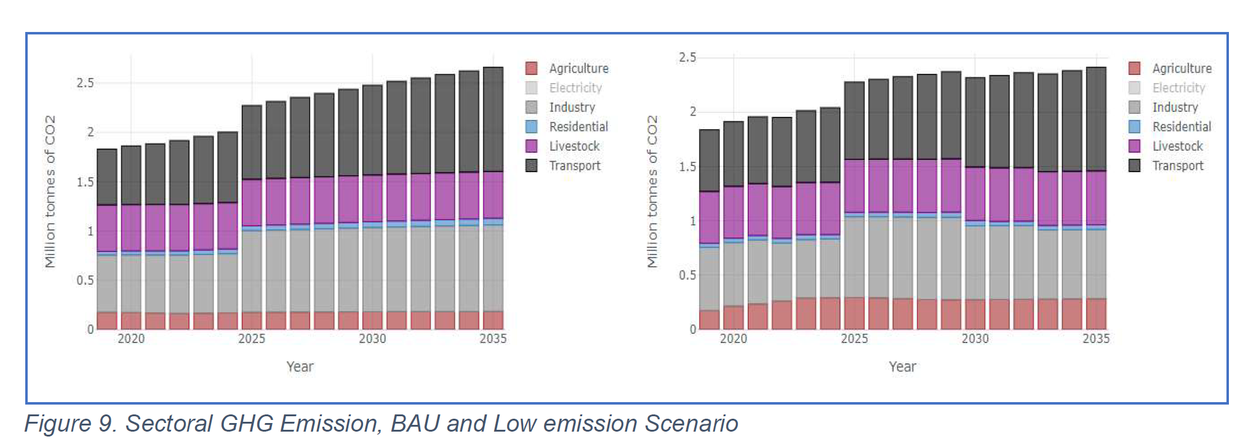
Food self-sufficiency targets appear achievable by using fallow land and some additional land from forest or other land covers. Climate change may reduce land needs by increasing yields for most crops, while irrigation and improved management practices can further reduce land requirements.

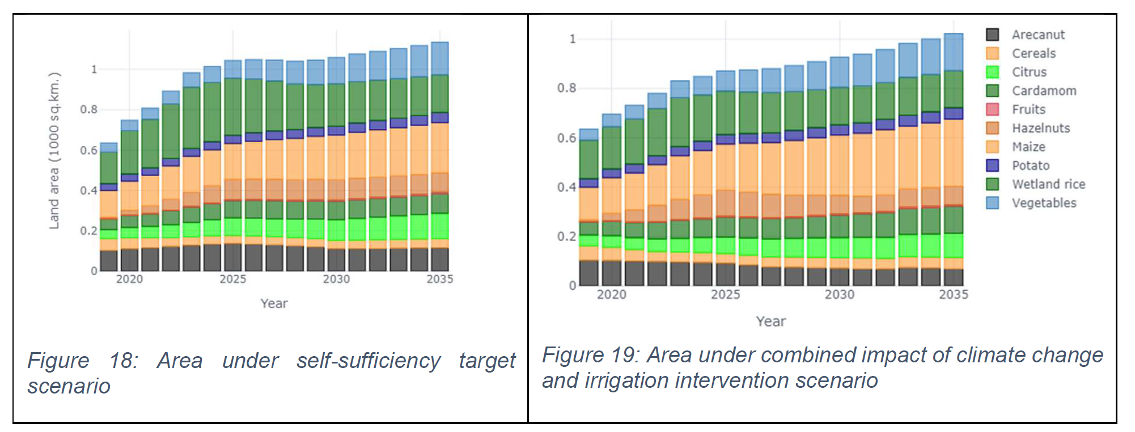
In brief:
- Industry: Industrial emissions rise with growth, requiring process-level mitigation such as fuel substitution, RDF in cement, direct hot charging in steel, and electrification of industrial processes.
- Energy: Hydropower supports Bhutan’s carbon-neutral pathway, but transport fuel demand remains a risk. The low-emission scenario reduces liquid petroleum demand by 15.36 PJ by 2035.
- Food security & land: Self-sufficiency is broadly feasible, but depends on irrigation, crop choice, productivity gains and careful land management. Full rice self-sufficiency remains difficult without major yield or wetland expansion. Climate change may increase yields (except maize and cardamom).

Resources: Bhutan CLEWS report
Models: OSeMOSYS
Stakeholders: National Environment Commission, Department of Agriculture, Department of Industry, Royal University of Bhutan, UNDP-BRH and Environment and Livelihood Cluster of UNDP Bhutan, UN DESA, KTH.
Tags: #Climate #EnergySecurity #FoodSecurity #Agriculture #FoodSecurity #Hydropower #CarbonNeutrality

SRI LANKA
When: 2020–2022
Purpose: To assess how Sri Lanka can meet rising electricity demand while expanding renewable energy, reducing dependence on imported fossil fuels, protecting land and water resources, supporting agriculture, and meeting its NDC and long-term decarbonization targets. The CLEWs model was used to explore cross-sector trade-offs across energy, land use, agriculture, forestry, climate, and water systems.
Although Sri Lanka has near-universal electrification, its power sector remains highly dependent on imported fossil fuels. Expanding renewable energy can reduce emissions and import dependence, but may create pressure on land and water resources, especially given policies to increase domestic food production and maintain rice self-sufficiency.
What happened: Sri Lanka participated in the UN DESA and UNDP Bangkok Regional Hub CLEWs Regional Training to inform NDCs in Asia-Pacific. The national team developed a CLEWs model using OSeMOSYS and tested three scenarios: Business as Usual, Existing Policy, and Perceived Policy.
The BAU scenario remains coal-heavy. The Existing Policy scenario increases renewables to about 50% of electricity generation. The Perceived Policy scenario tests a more ambitious pathway of 70% clean electricity by 2030, including 50% renewables and 20% natural gas. The model covers 2020–2050, with 2030 policy targets and carbon neutrality by 2050.
Key insights: Sri Lanka’s decarbonization pathway is technically plausible, but requires integrated planning beyond the power sector. Renewable energy expansion can reduce emissions at relatively low additional system cost, but grid stability, storage, transmission, reserve margin, land allocation, and local social and environmental impacts need to be explicitly considered.
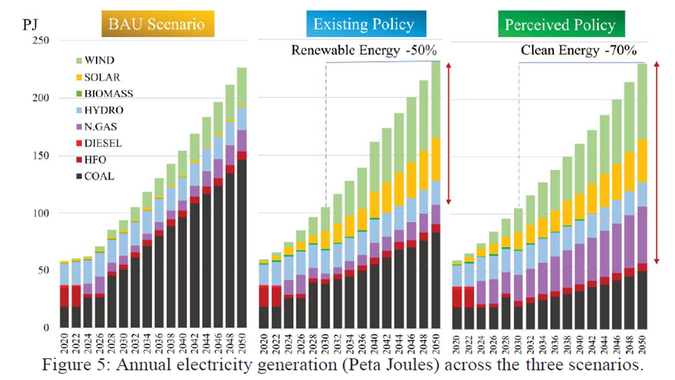
Under BAU, power-sector emissions rise roughly fourfold by 2050. Existing Policy and Perceived Policy scenarios reduce emissions by about 32% and 44%, respectively, relative to BAU. Costs increase modestly, by around +1% and +4%, excluding grid-integration and legacy infrastructure costs. Renewable energy land needs are estimated at about 7.6% of available grass and scrublands, which is small nationally but may still create local land-use conflicts.
Resources:
https://www.researchgate.net/publication/379898016_EMISSION_REDUCTION_POTENTIAL_AND_LAND-USE_IMPLICATIONS_OF_DECARBONISING_THE_POWER_SECTOR_IN_SRI_LANKA
https://www.iam-compact.eu/sites/default/files/2025-08/Policy_Brief_Sri%20Lanka%27s%20Sustainable%20Energy%20Future.pdf
Second resource is a CLEWs update, outside of the first project but with same guiding questions.
Model: OSeMOSYS
Stakeholders:UN DESA and UNDP, including UNDP HQ, the Bangkok Regional Hub, and UNDP Sri Lanka, with KTH and local and national institutions including the Ceylon Electricity Board, Rajarata University of Sri Lanka, and the University of Moratuwa.
Tags: #RenewableEnergy #NDC #CLEWs #PolicyAnalysis

